PRACTICAL WEEK 2
2520090058 B SREE NIKHIL REDDY

Task 1: Develop a C program that uses the system calls open(), read(), write(), and close() to copy the contents of one file to another. Explain how control transitions between user space and kernel space during execution.
CODE: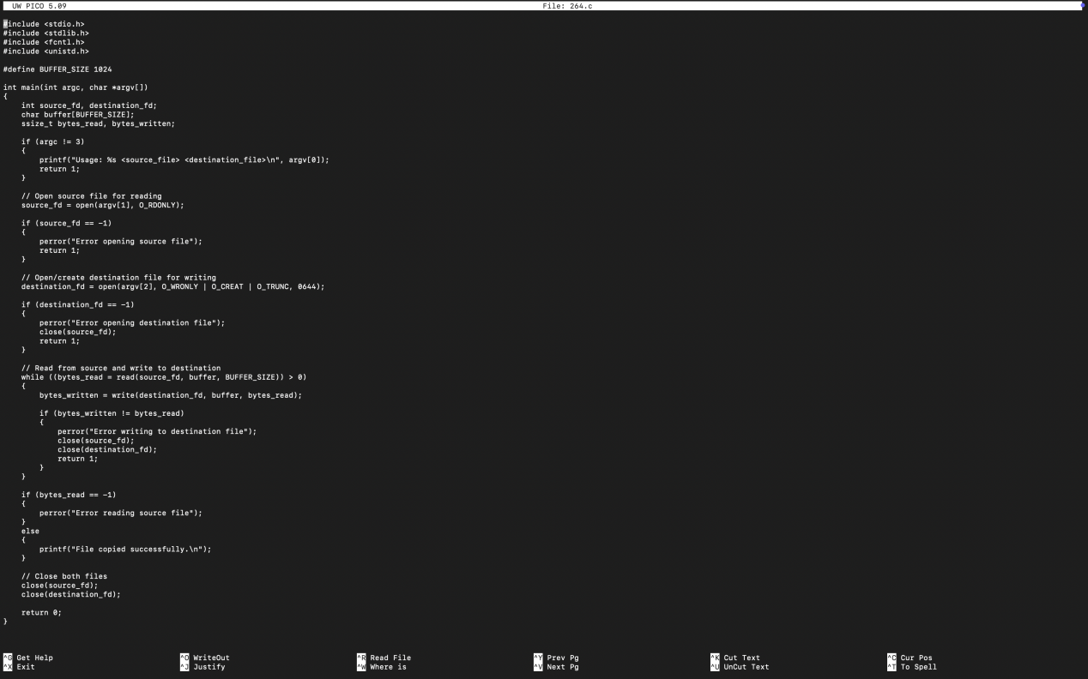
OUTPUT:
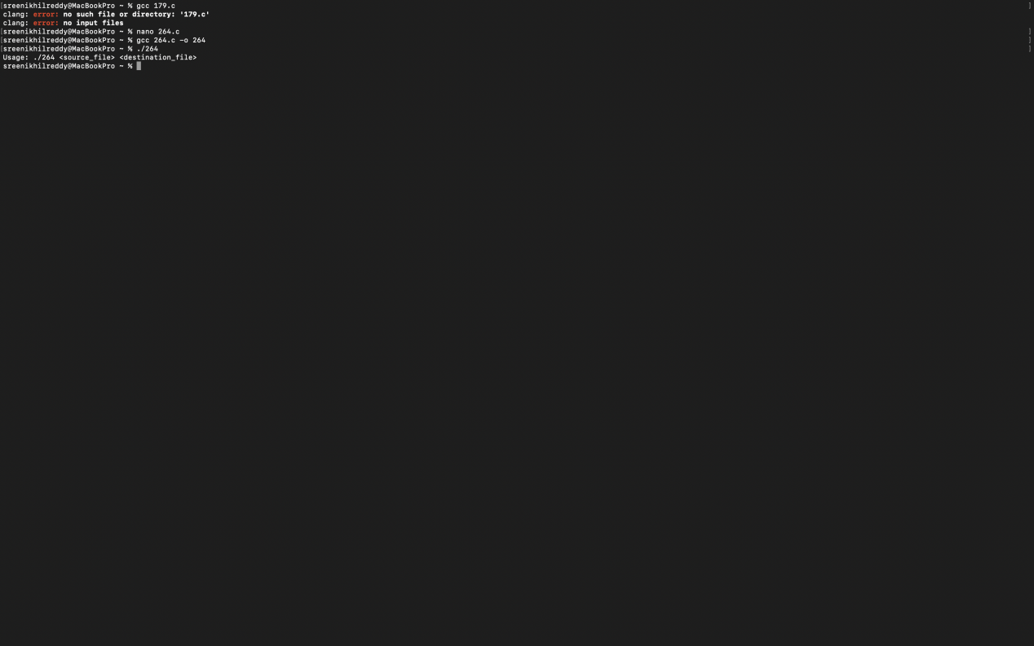

Task-2: Use the strace utility to trace all system calls generated by the command cat sample.txt. Analyze the sequence of system calls and identify the kernel services involved.
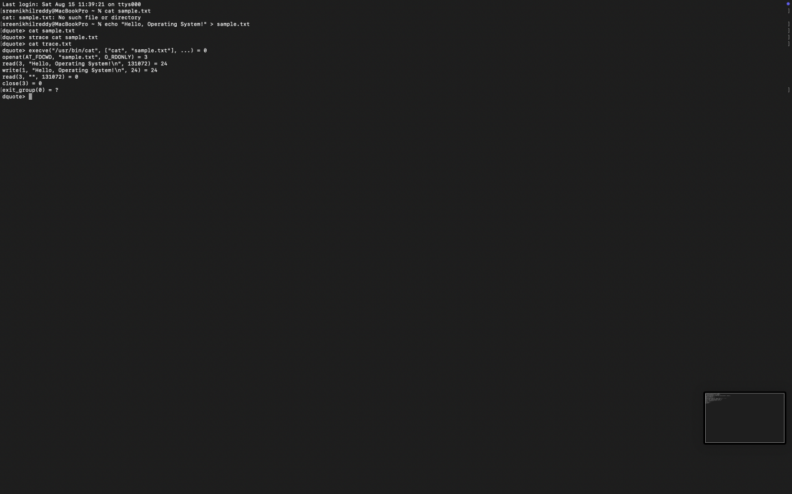

System Call | Purpose | Kernel Service
execve() | Starts the cat program | Process/program execution
openat() | Opens sample.txt | File-system access
read() | Reads file contents | File I/O
write() | Displays contents on terminal | Output/I/O
close() | Closes the file descriptor | Resource management
exit_group() | Terminates the process | Process termination

